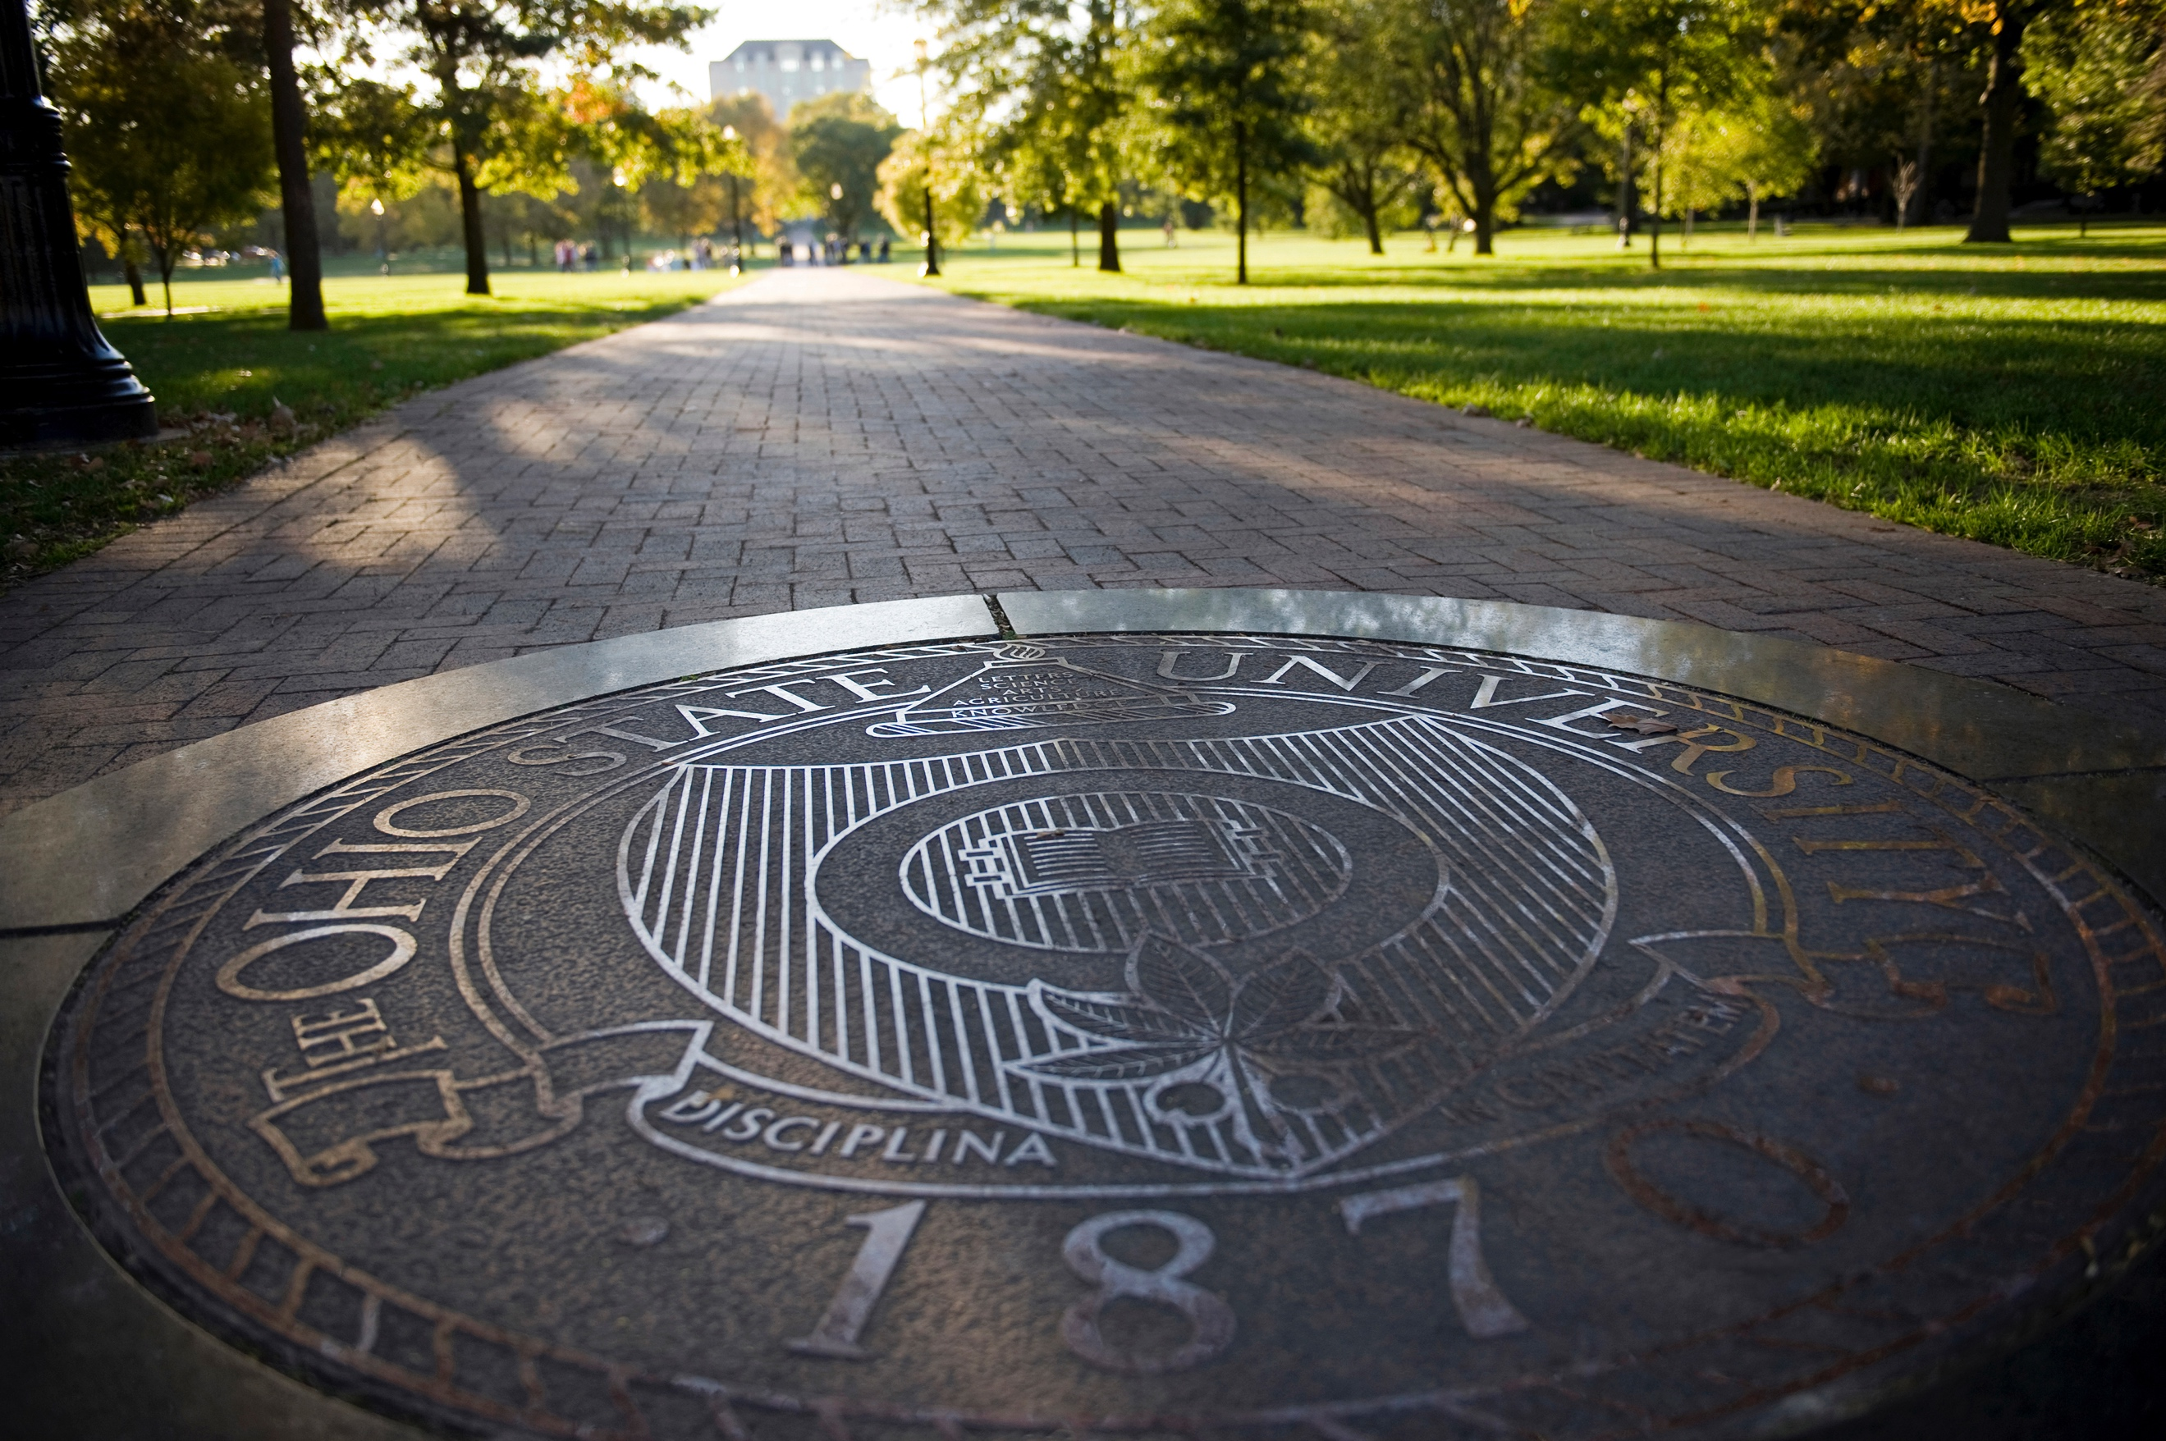

DEPARTMENTAL FORMS

DISSERTATION PROSPECTUS FORM

The purpose of this form is to check the student’s progress towards completing the candidacy exam and to establish the candidacy examination committee. This form needs to be submitted to the Graduate Studies Committee in the 4th week of the semester in which the student plans to take the candidacy exam.

Date
Student name
Anticipated date of candidacy exam

The dissertation prospectus serves as the first draft of the dissertation research proposal and must include: research questions and/or hypotheses, the theoretical frameworks guiding the proposed work, and planned methodological approach. Please write a summary of the dissertation research proposal below and attach the latest draft of the proposal.

The candidacy examination committee is composed of at least four authorized graduate faculty members, including the student’s advisor. Only one member of the candidacy examination committee can be from another department at the Ohio State University. Any committee members from outside of the Ohio State University must be added as a fifth member by petition to the Graduate School. By signing this form, the committee members indicate that they approve the dissertation prospectus.

Name | Department | Signature (advisor) | Date
Name | Department | Signature (committee member) | Date
Name | Department | Signature (committee member) | Date
Name | Department | Signature (committee member) | Date
Name | Department | Signature (committee member) | Date

READY FOR CANDIDACY FORM

The purpose of this form is to check whether the student made sufficient progress towards completing the candidacy exam and is ready to take the candidacy examination this semester or needs to take the candidacy examination in the next semester. This form needs to be submitted to the Graduate Studies Committee by the end of the 12th week of the semester in which the student plans to take the candidacy exam.

Date
Student name
Anticipated date of candidacy exam

The candidacy examination committee has reviewed the attached dissertation proposal and determined that the student is ________________ (ready / not ready) to take the candidacy exam this semester.

Name | Department | Signature (advisor) | Date
Name | Department | Signature (committee member) | Date
Name | Department | Signature (committee member) | Date
Name | Department | Signature (committee member) | Date
Name | Department | Signature (committee member) | Date

READY TO DEFEND DISSERTATION FORM

The purpose of this form is to check whether the student made sufficient progress towards completing the dissertation and is ready to take the Final Oral Examination this semester. This form needs to be submitted to the Graduate Studies Committee by the end of the 3rd week of the semester in which the student plans to take the final oral examination.

Date
Student name
Anticipated date of final oral examination

The final examination committee has read and reviewed the complete dissertation and determined that the student is ________________ (ready / not ready) to take the final oral examination this semester.

Name | Department | Signature (advisor) | Date
Name | Department | Signature (committee member) | Date
Name | Department | Signature (committee member) | Date
Name | Department | Signature (committee member) | Date
Name | Department | Signature (committee member) | Date

MASTER’S EXAMINATION FORM

The purpose of this form is to check whether the student meets all the minimal requirements for the master’s examination, specify the format of the master’s examination, and establish the master’s examination committee. This form needs to be submitted to the Graduate Studies Committee in the 4th week of the semester.

Date
Student name
Anticipated graduation date

Minimum Requirements for the Master’s Degree is the completion of the core courses of the graduate program and three electives (30 credit hours). Students must pass these courses with a B- or higher and have a cumulative grade-point average of at least 3.0. Please attach a student advising report this form.

Course | Credit Hours | Grade | Semester
7001 Society and Environment | 3
7002 Anthropology of Health | 3
7003 Human Evolutionary History | 3
5005 Applied Quantitative Methods | 3
8891.05 Ethnographic Methods | 3
7720 Teaching Anthropology | 3
8827 Communicating Anthropology | 3
Elective 1:
Elective 2:
Elective 3:
Total credit hours and cumulative GPA

Format of the Master’s Examination. The master’s examination assesses the student’s knowledge of the field. It is the final validation of performance for the degree. The written portion may be a comprehensive exam, substantial paper, project, or portfolio demonstrative of scholarly work and consistent with best practices in the field. Please describe below what the format of the master’s examination will be.

The Master’s Examination Committee is composed of the following three graduate faculty members. By signing this form, the committee members indicate that they approve the format of the master’s examination described above.
Name | Signature (advisor) | Date
Name | Signature (committee member) | Date
Name | Signature (committee member) | Date

ACADEMIC PORTFOLIO FORM

The purpose of this form is to check students’ progress to completion of the graduate program and their progress towards their career goals. The narratives in the academic portfolio focus on the activities and achievements of the last twelve months, i.e., the previous calendar year. This form needs to be submitted to the graduate program coordinator (GPC) by the end of the 4th week of the spring semester.

Date
Student name
Advisor name
Term entered program
Date of candidacy examination (or anticipated)
Date of final oral examination (or anticipated)
Date of master’s examination (if applicable)

Please attach the following materials to the portfolio:
- Curriculum vitae, with research, teaching, and other activities and achievements.
- Student advising report.
- Cumulative SEI report and SEIs for courses taught.
- Copies of publications (if any).
Committees Students will work with one to three committees over the course of the graduate program. If students opt to obtain a master’s degree, they will work with their Master’s Examination Committee (also called MA committee). When students prepare for and take the candidacy exam, they will work with the Candidacy Examination Committee (also called candidacy committee). And when students work on their dissertation research and defend their dissertation in the final oral examination, they will work with the Final Oral Examination Committee (also called dissertation committee). Please indicate in the form below your current committee (if any) and its members (add affiliation if members are not faculty of the anthropology department).

Type of committee:
Name advisor | Department
Name | Department
Name | Department
Name | Department
Name | Department

Course Requirement. Students must pass courses with a B- or higher and have a cumulative grade-point average of at least 3.0. Please indicate electives you have taken and how many credit hours of workshops and individual studies you have completed.

Course | Credit Hours | Grade | Semester
7001 Society and Environment | 3
7002 Anthropology of Health | 3
7003 Human Evolutionary History | 3
7101 Research Design | 3
5005 Data Analysis in Anthropology | 3
8891.05 Ethnographic Methods | 3
7720 Teaching Anthropology | 3
8827 Communicating Anthropology | 3
8828 Grant Writing | 3
7007 Academic Workshop
7777 Data Collection Workshop
Elective 1
Elective 2:
Elective 3:
Elective 4 (methods):
Total individual study credit hours
Total credit hours and cumulative GPA

Briefly describe your professional goals after completing your degree and the steps you have taken to prepare for them, including the development of professional collaborations and networks within the department.

Briefly describe your progress in the program focusing on the activities and progress in the last twelve months.

Briefly describe your service activities and accomplishments in and outside the department (e.g., service on committees, outreach and engagement activities, reviewing manuscripts, mentoring students), focusing on the activities and progress in the last twelve months.

Briefly describe your teaching activities and accomplishments, focusing on how you used formative and summative assessments to improve your teaching in the last twelve months.

The department recognizes the impact that life has on your academic activities. This can be family responsibilities, health problems, including mental health. We will consider the impact of life’s challenges when assessing your progress towards degree completion and career goals. Below you can briefly describe how life affected your progress towards degree completion.

You can also let your advisor, GSC chair, or another trusted person know about life impacts on your progress in the program. This information will be kept confidential to protect your privacy.

GTA APPLICATION FORM

The purpose of this form is to assess student needs and preferences for GTA positions. This form needs to be submitted to the Graduate Studies Committee in the 10th week of the semester.

Date
Student name
Advisor name
Term entered program
Date candidacy examination (or anticipated)
Date final oral examination (or anticipated)
Date master’s examination (if applicable)

Do you want a GTA position for the coming academic year? Both semesters?

What classes do you want to teach? List in order of preference

Do you prefer to teach online or in-person? Provide a reason for teaching online.

Summer Teaching Positions. There are limited opportunities to teach in the summer and we try to divide the teaching opportunities equitably. Therefore, the number of times you can teach summers is limited to two. This limit does not apply to the graduate teaching fellow or if we cannot fill the positions with students who have taught fewer than two summer.

Do you want to teach in the coming summer?

How my many summers have you taught previously?

Teaching record. The limit of semesters that students can work as graduate teaching associates in the department is 10. Please fill out the table below and indicate what courses you have taught, when you taught them (in chronological order), and what your SEI score was for each class.

Course number and name | Semester taught | SEI
Scheduling. We are trying to schedule teaching assignments so that they do not conflict with your course schedule. Please indicate below what courses you are taking in the coming academic year.

Autumn semester
Course number and name, days and times
Spring semester
Course number and name, days and times

Graduate Teaching Fellow. If you want to be considered for the graduate teaching fellow (GTF) position, please explain below why you would an excellent candidate for this position.

The GTF position is a 25% position that is combined with a 50% GTA position. The main responsibilities are support the graduate teaching associates in the department, which includes organizing and leading the orientation of new GTAs, sending reminder emails to GTAs, assist with management of master courses, organizing lab schedules for 2200, and organize the GTA appreciation lunch in the spring semester.

